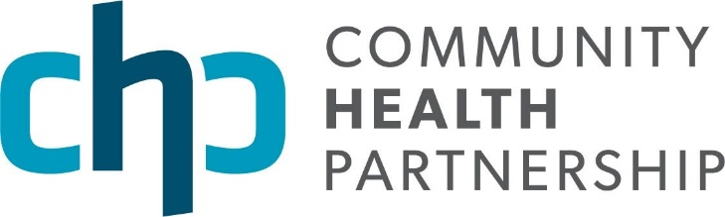

El Paso County’s suicide rate is one of the highest in the nation and the state (CDPHE, 2019). This is a designation that Community Health Partnership’s (CHP) members, and the broader community, want to change by identifying and addressing suicide as a “critical health issue” in the Pikes Peak region. As a critical issue, CHP will convene and develop a local collaborative infrastructure to prevent suicides by implementing a community health model. This model pushes us to think beyond a typical medical and/or behavioral health approach. “The scale of the problem is such that we cannot ‘therapize’ our way out of it. Mental health treatment is critical but insufficient to reduce suicides. We need to develop solutions that go beyond the traditional clinical approach to preventing suicides – we need community-based, non-clinical approaches as well,” said Cari Davis, C.E.O. of Colorado Springs Health Foundation.
Tyler Carpenter of AspenPointe agreed with this approach by stating, “Clinical and behavioral health providers are prepared to do their part by providing counseling, medications, and case management - to name a few broad interventions. However, we need to ask ourselves, ‘What happens after an individual completes a therapy or prescriber appointment, or what happens after a person is discharged from an inpatient level of care? What do we have in place to provide wrap-around care for individuals who need community support?’ Life continues in between appointments and hospitalizations, and often, there are not enough support systems in place to address these gaps. Why not help restaurant servers or baristas identify a potential crisis and feel comfortable offering support? Everyone in our organizations should be trained to identify and intervene if someone is in crisis. We cannot only rely on the behavioral health system to support people in crisis. It is a community responsibility and we need to help others fill these gaps.”
To do this will require a shift to systems thinking, according to CHP Interim CEO, Amber Ptak. “Suicide prevention is a complex problem and one that requires a new way of thinking and organizing. Systems thinking will provide us the ability to see how organizational systems interact with and influence each other, and how their systems create and contribute to specific problems. We need systems change, which is to shift the conditions that hold the problems in place.
“One evidence-based strategy the county should consider implementing is Zero Suicide. Zero Suicide is a set of best practices, as well as a goal, that requires healthcare settings to screen ALL patients for feelings of depression and/or thoughts of suicide. If a patient is at risk, then a series of interventions take place to support the patient. We should take every opportunity to check in with people about their mental health.” –Andrea Wood

While a reduction in suicide attempts and completions is a powerful indicator, we need to think more broadly about how we create a community where people feel connected and can access resources when and where they need them. We shouldn’t limit our support to an already overburdened behavioral health system.”
Andrea Wood, UCHealth Memorial Hospital’s Zero Suicide Coordinator stated, “In the month before their death by suicide, 50% of people saw a general practitioner, 50% saw a mental health professional, and 83% saw a healthcare professional. In the 60 days prior to their death by suicide, 30% of people were seen in an emergency department for a non-behavioral health intervention. Better approaches to suicide care are available, effective, and they help fill in the gaps that exist in our healthcare delivery system. We can do better. Implementing Zero Suicide county-wide can help get us there.”
Meghan Haynes from El Paso County Public Health believes a reduction in suicide attempts and completions is attainable through a collective impact approach. In her role as the Teen Suicide Prevention Planner, Meghan has seen collaborative efforts have a positive impact. “Over the last three years, we have seen El Paso County’s youth suicide rate decline by 40 percent. We believe this reduction is due, in large part, to the dedicated and collaborative work of the Youth Suicide Prevention Workgroup.”
While continuing the county’s dedication to reducing the teen suicide rate, CHP will work with dozens of local partners to develop data-driven and systems-based approaches to support people who are at greatest risk of a suicide attempt. According to Melissa Hansen, CHP’s Suicide Prevention Project Manager, the population at greatest risk of an attempt and/or completion are working-age males. “To lower the suicide rates among this population, we must expand our thinking about what constitutes suicide prevention. We don’t have a clear answer as to why this population has the highest rates of attempts and completions, but we do know that we have to create ways for working-age males to connect with their community, to increase economic stability and resilience, and to educate families about firearm safety before and during a crisis.”
CHP is working closely with local partners, the Colorado Department of Public Health & Environment, and the Centers for Disease Control and Prevention to develop a collective impact approach to suicide prevention in the region. If you would like to learn more, please contact Melissa Hansen at Melissa.Hansen@ppchp.org.

