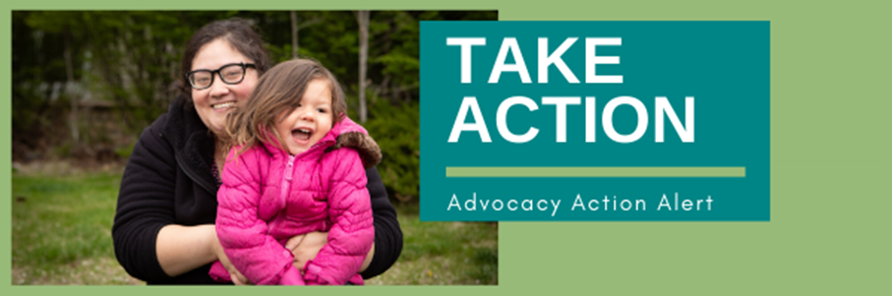

|  |  |  |  |  |
| --- | --- | --- | --- | --- |
| |  |  |  |  | | --- | --- | --- | --- | | |  |  |  | | --- | --- | --- | | |  |  | | --- | --- | | |  | | --- | | Election Day is months away, but the season for ballot initiatives is in full swing. You may be approached by signature gatherers looking for your support of [Initiative 122](https://default.salsalabs.org/T9e850193-8a42-44f3-9253-ec38ac396b7e/fb340f8f-25ac-42b4-bd4e-8f733efcb87e).  Initiative 122 is a statewide measure that caps growth and housing in the 11 Front Range counties. While the proposal may sound fine on first reading, the details make this initiative harmful to Colorado.  First, Initiative 122 deceptively includes a slightly higher allowance for affordable housing. But with our region being more than 20,000 affordable units behind, **Initiative 122 will make affordable housing near impossible to build.**  Second, Initiative 122 will push development into rural counties and cause urban sprawl to **replace farmland and natural areas**, while **making traffic congestion even worse** for Coloradans.  Finally, Initiative 122 would **limit the supply of housing, driving up the price of homes and apartments**, and placing much of that burden on working families, seniors and Coloradans on fixed incomes. | | | | |
|  |
|  |